Online Diary- Joshua Baker

04/10/2020

Today is my first entry into my online diary. The goal for this diary is to record everything we did within our lessons, helping me reflect upon what needs to be done and what I can do better in the future.

Today I participated in a group of 3 (myself, Sienna Jenkins and Zakaria Ahmed) to create a game around employability skills. Our game was called “persuasion” and it revolved around a random name generator to pick random topics from a given list. The idea of the game is to get 2 different people to argue and debate their topics, with a 3rd party person giving a vote to the person who presented their topic better. We tried to focus on communication skills and presentation. The topics were different for both people but they both had the same question addressed to them, this question is also randomly chosen.

Unfortunately, we could not physically make an actual game as we had to create this game online. So, there was no material used, we created the game by using a random name generator: <https://wheelofnames.com/> Not only this but because of the complications of being online we did not have enough time to do play testing with other groups. I feel our game was affected very poorly because of this because we did not have an outside look/opinion on how our game could be improved.

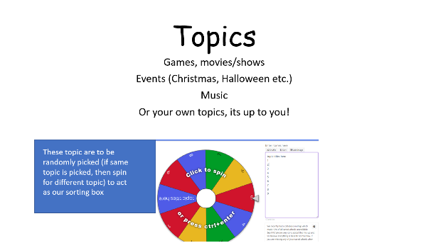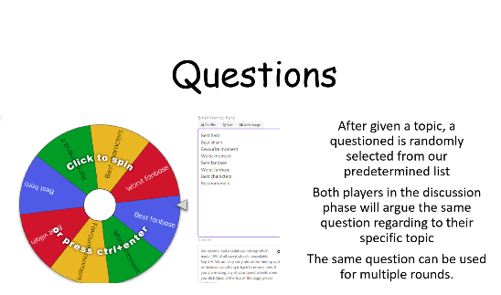

I think I personally did not learn any new key employability skill during this activity, but it did help me strengthen my knowledge of these skills as I was personally tested on my knowledge of these skills during the activity multiple times. The most important being skills like presentation, communication, confidence and even teamwork. which are the skills that I really tried to focus on for the activity.

I think team work and leadership for this activity was especially challenging because of the conditions everyone was in for our team (being online) it was harder for some to present their ideas and it was more challenging to get everyone to contribute to the task than being face to face. I think teamwork is the most important employability skill, it is the most productive skill, as it involves other skills like communication and leadership. I think there wasn’t much that I did well unfortunately for this task, I would like to hope my communication was good as I tried to clearly present my ideas across, getting the team to work together by asking everyone questions and challenging my team on their own ideas. There are a lot of things I would like to improve, such as my presentation and my awareness of the points that were required as we failed to address them all.